**BA EXPERIMENT 3**

**DESCRIBE MISSING DATA:**

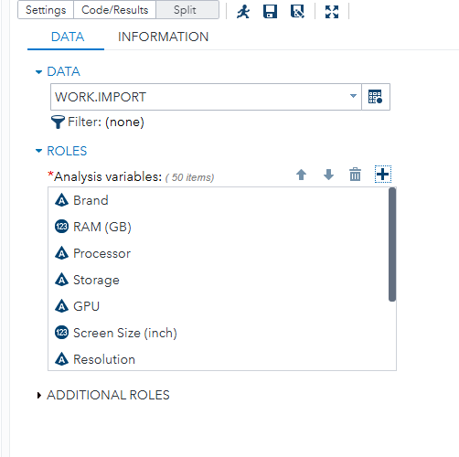

CODE:

ods noproctitle;

proc format;

value _nmissprint low-high="Non-missing";

value $_cmissprint " "=" " other="Non-missing";

run;

proc freq data=WORK.IMPORT;

title3 "Missing Data Frequencies";

title4 h=2 "Legend: ., A, B, etc = Missing";

format 'RAM (GB)'n 'Screen Size (inch)'n 'Battery Life (hours)'n

'Weight (kg)'n 'Price ($)'n _nmissprint.;

format Brand Processor Storage GPU Resolution

'Operating System'n $_cmissprint.;

tables Brand 'RAM (GB)'n Processor Storage GPU 'Screen Size (inch)'n

Resolution 'Battery Life (hours)'n 'Operating System'n 'Weight (kg)'n

'Price ($)'n / missing nocum;

run;

proc freq data=WORK.IMPORT noprint;

table Brand * 'RAM (GB)'n * Processor * Storage * GPU * 'Screen Size (inch)'n

* Resolution * 'Battery Life (hours)'n * 'Operating System'n * 'Weight (kg)'n

* 'Price ($)'n / missing out=Work._MissingData_;

format 'RAM (GB)'n 'Screen Size (inch)'n 'Battery Life (hours)'n

'Weight (kg)'n 'Price ($)'n _nmissprint.;

format Brand Processor Storage GPU Resolution

'Operating System'n $_cmissprint.;

run;

proc print data=Work._MissingData_ noobs label;

title3 "Missing Data Patterns across Variables";

title4 h=2 "Legend: ., A, B, etc = Missing";

format 'RAM (GB)'n 'Screen Size (inch)'n 'Battery Life (hours)'n

'Weight (kg)'n 'Price ($)'n _nmissprint.;

format Brand Processor Storage GPU Resolution

'Operating System'n $_cmissprint.;

label count="Frequency" percent="Percent";

run;

title3;

proc delete data=Work._MissingData_;

run;

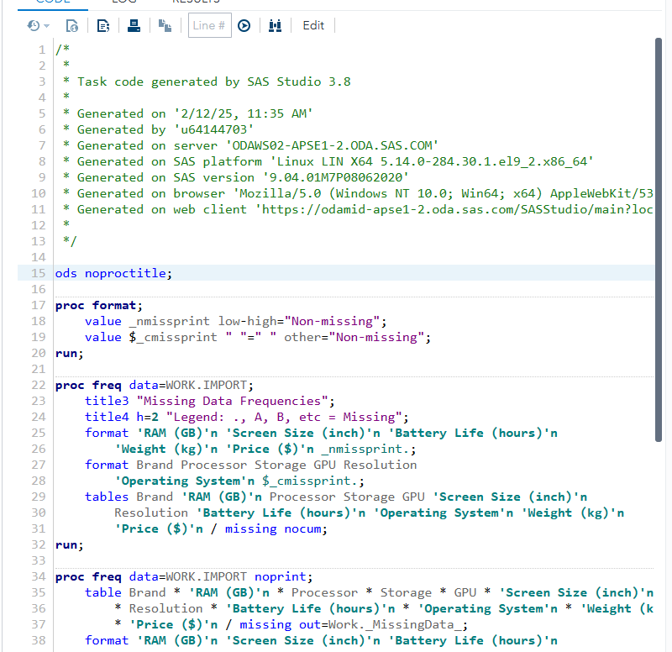

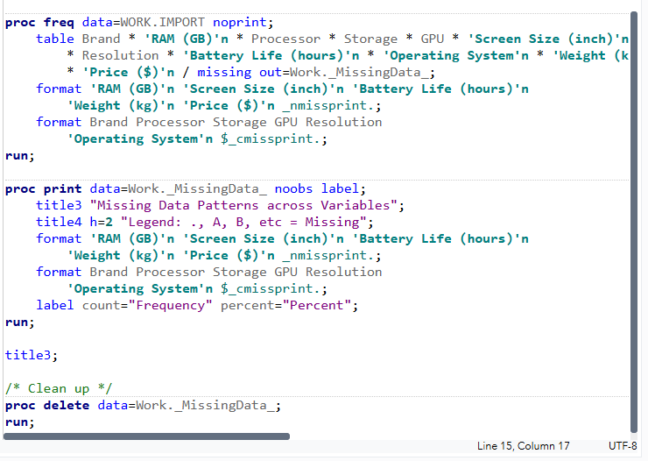

RESULTS:

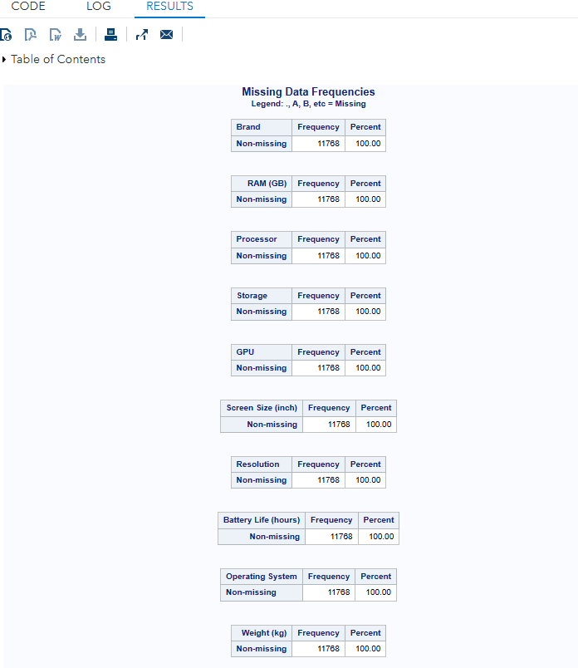

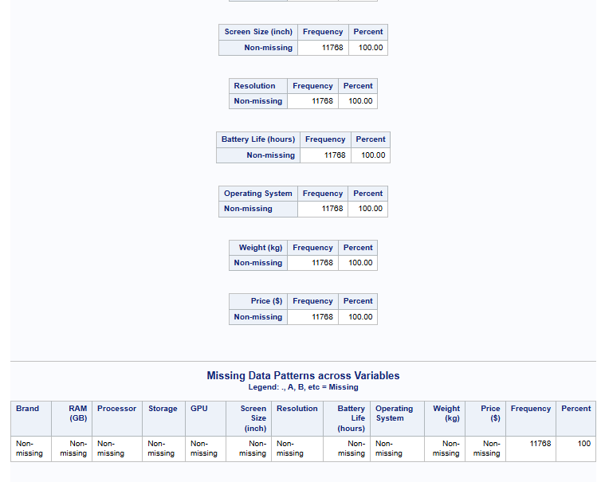

**STANDARIZE DATA:**

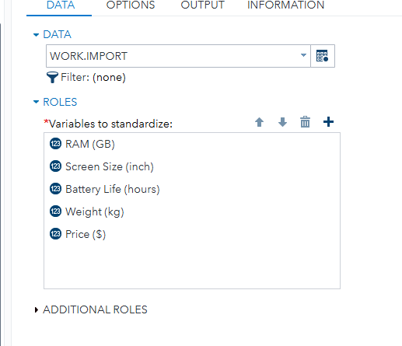

CODE:

ods noproctitle;

proc stdize data=WORK.IMPORT method=std nomiss out=work.Stdize oprefix

sprefix=Standardized_;

var 'RAM (GB)'n 'Screen Size (inch)'n 'Battery Life (hours)'n 'Weight (kg)'n

'Price ($)'n;

run;

OUTPUT DATA:

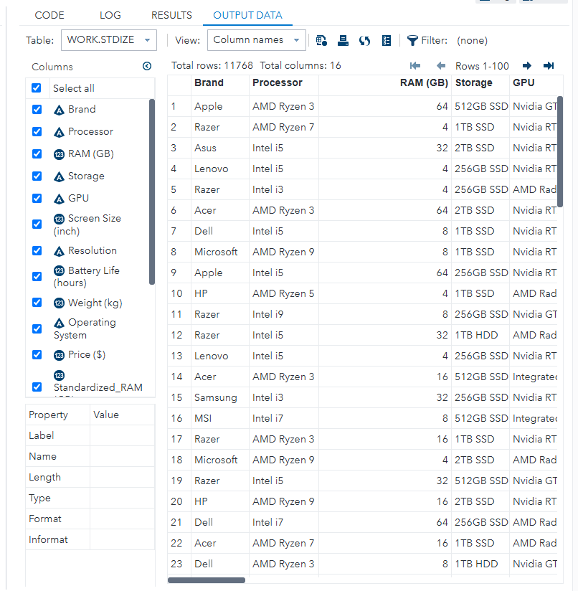

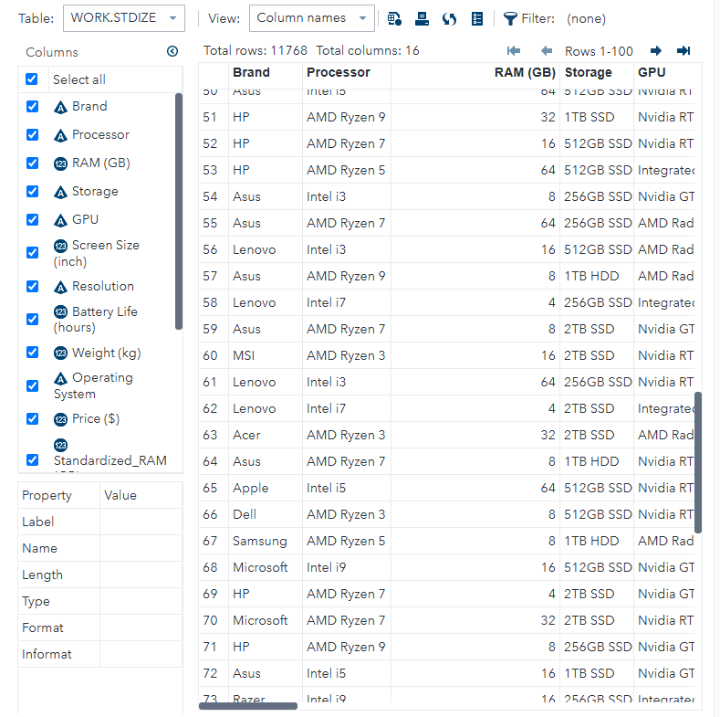

**FILTER DATA:**

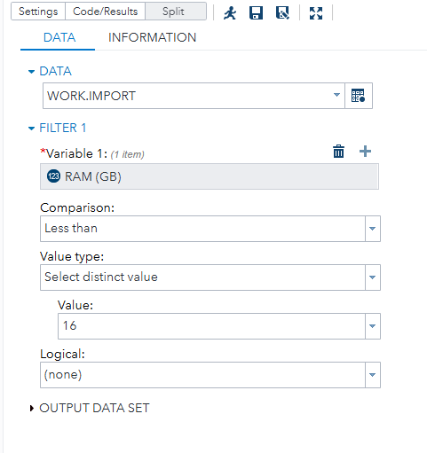

INPUT:

proc sql noprint;

create table work.filter as select * from WORK.IMPORT where('RAM (GB)'n LT

input('16', BEST12.) );

quit;

OUTPUT DATA:

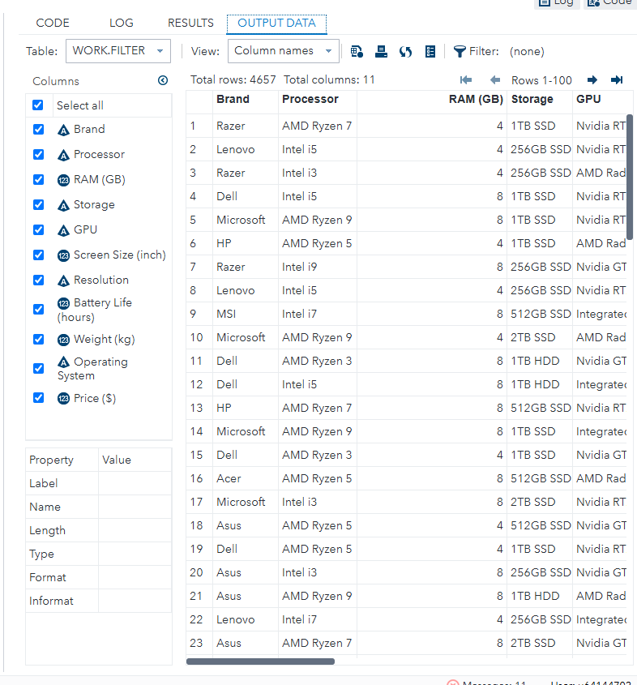

**GRAPH:**

INPUT:

ods graphics / reset width=6.4in height=4.8in imagemap;

proc sgplot data=WORK.IMPORT;

vbar 'RAM (GB)'n /;

yaxis grid;

run;

ods graphics / reset;

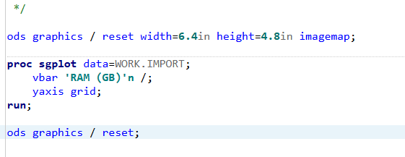

RESULTS:

